# 1.dealerC:\Users\Computer Mine's\AppData\Local\Packages\Microsoft.Windows.Photos_8wekyb3d8bbwe\TempState\ShareServiceTempFolder\Screenshot (32).jpeg

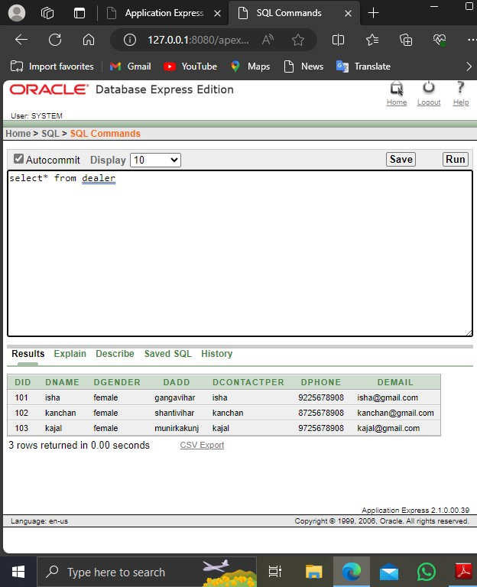

2.vendor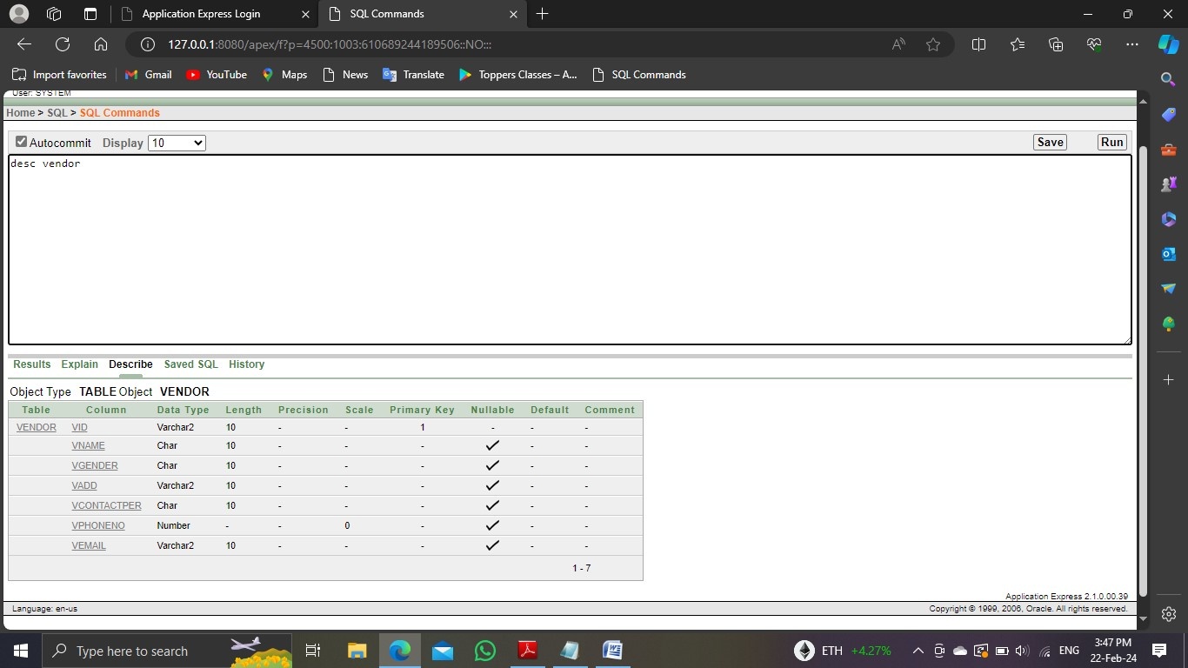

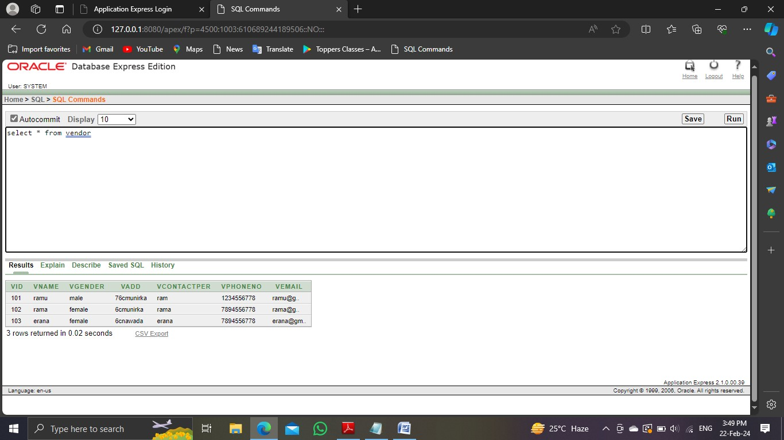

# 3.purchase

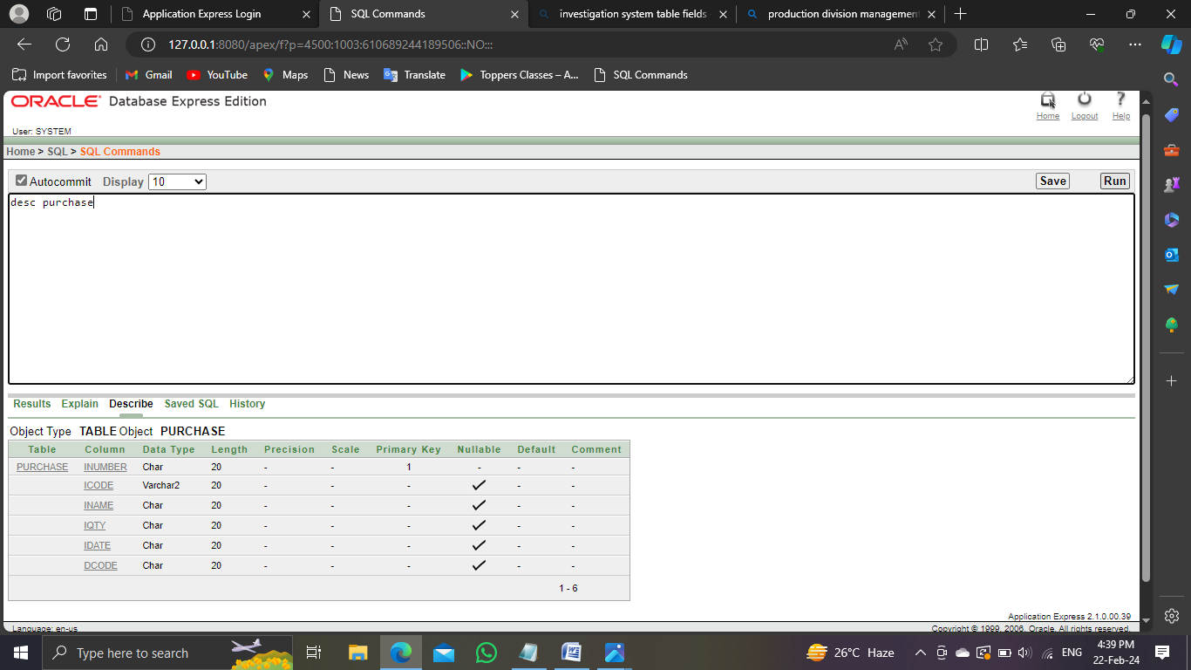

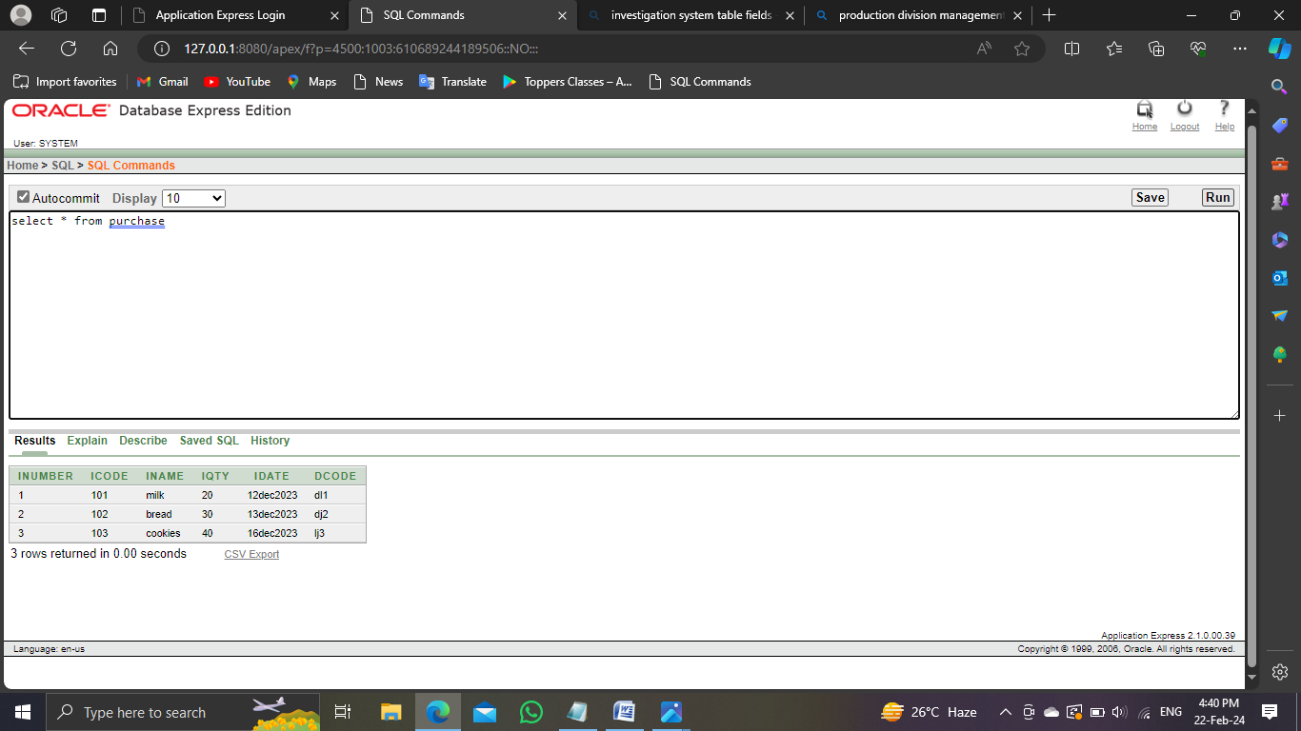

# SALEs MANAGEMENT

4.sales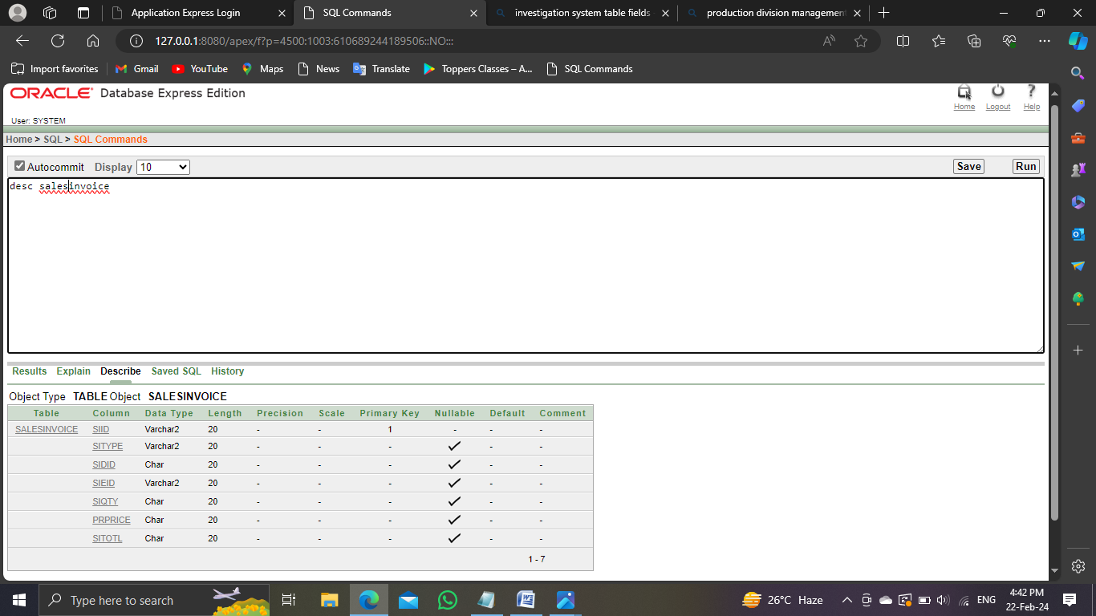

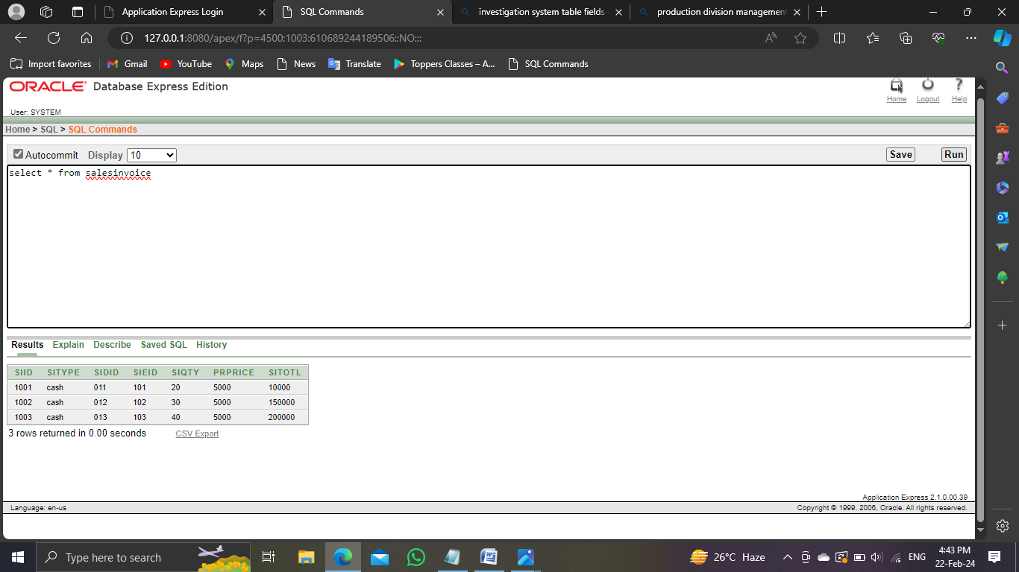

# 5.employee

# 

# 6.authenticaton

# 7.transaction

# investigation

# production